Celebrating Individuals with Disabilities
________________Parish/Church__________________
_______________Phone #_______________________
_________________Website______________________

To the parents and caregivers of our brothers and sisters with disabilities, may we suggest…

- Relax! God put the wiggles and noises in all of us; don’t feel you have to suppress them in His house.
- Sit toward the front where it is easier to see and hear.
- Quietly explain the parts of the Mass and use the Missal to assist in following the Mass parts.
- Sing the hymns, pray, and voice the responses; liturgical behavior is learned by watching good examples.
- If you need to leave Mass for any reason, please feel free to do so, but please come back!
  - You are invited to visit our Quiet Area _(list a quiet location available or remove this sentence on form)_________________
- Feel free to bring sensory/fidget tools with you.

To the members of our parish…

- May you also remember that the way we welcome others into the Church directly impacts the way they respond to the Church, to God, and to Christ. Let them know they are at home here!
- A smile of encouragement is always welcome!
- Recognize that individuals with disabilities have been given a unique vocation by God, Himself. Reflect carefully on what special gifts others have to share with you and what their presence might teach you.

Celebrating Individuals with Disabilities
________________Parish/Church__________________
_______________Phone #_______________________
_________________Website______________________

To the parents and caregivers of our brothers and sisters with disabilities, may we suggest…

- Relax! God put the wiggles and noises in all of us; don’t feel you have to suppress them in His house.
- Sit toward the front where it is easier to see and hear.
- Quietly explain the parts of the Mass and use the Missal to assist in following the Mass parts.
- Sing the hymns, pray, and voice the responses; liturgical behavior is learned by watching good examples.
- If you need to leave Mass for any reason, please feel free to do so, but please come back!
  - You are invited to visit our Quiet Area _(list a quiet location available or remove this sentence on form)_________________
- Feel free to bring sensory/fidget tools with you.

To the members of our parish…

- May you also remember that the way we welcome others into the Church directly impacts the way they respond to the Church, to God, and to Christ. Let them know they are at home here!
- A smile of encouragement is always welcome!
- Recognize that individuals with disabilities have been given a unique vocation by God, Himself. Reflect carefully on what special gifts others have to share with you and what their presence might teach you.

Celebrating Individuals with Disabilities
________________Parish/Church__________________
_______________Phone #_______________________
_________________Website______________________

To the parents and caregivers of our brothers and sisters with disabilities, may we suggest…

- Relax! God put the wiggles and noises in all of us; don’t feel you have to suppress them in His house.
- Sit toward the front where it is easier to see and hear.
- Quietly explain the parts of the Mass and use the Missal to assist in following the Mass parts.
- Sing the hymns, pray, and voice the responses; liturgical behavior is learned by watching good examples.
- If you need to leave Mass for any reason, please feel free to do so, but please come back!
  - You are invited to visit our Quiet Area _(list a quiet location available or remove this sentence on form)_________________
- Feel free to bring sensory/fidget tools with you.

To the members of our parish…

- May you also remember that the way we welcome others into the Church directly impacts the way they respond to the Church, to God, and to Christ. Let them know they are at home here!
- A smile of encouragement is always welcome!
- Recognize that individuals with disabilities have been given a unique vocation by God, Himself. Reflect carefully on what special gifts others have to share with you and what their presence might teach you.

Church/Parish Name____________
Phone #_________________
Website_______________

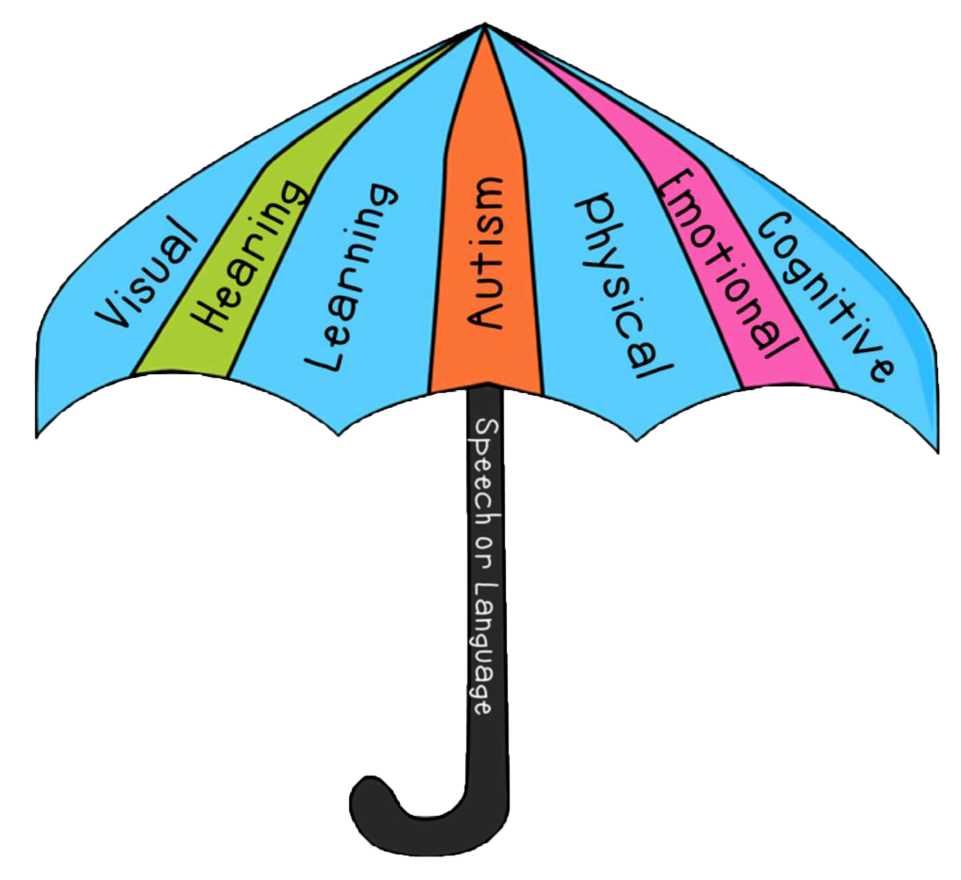

For questions and support contact: Patty Origer 515-237-5073 or poriger@dmdiocese.org
Check us out at: www.dmdiocese.org/disabilityministry

Thank you St. Francis of Assisi for sharing this form with us
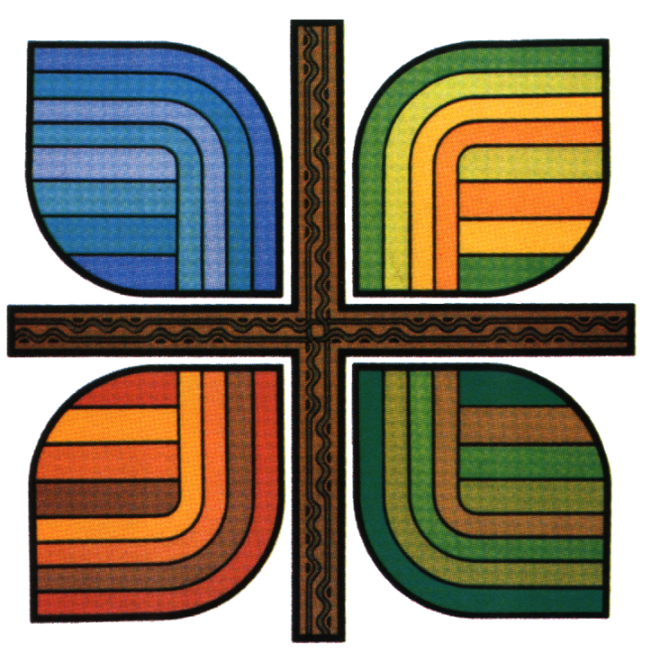
Diocese of Des Moines
601 Grand Avenue
Des Moines, IA 50309
515-243-7653
www.dmdiocese.org

Church/Parish Name____________
Phone #_________________
Website_______________

For questions and support contact: Patty Origer 515-237-5073 or poriger@dmdiocese.org
Check us out at: www.dmdiocese.org/disabilityministry

Thank you St. Francis of Assisi for sharing this form with us
Diocese of Des Moines
601 Grand Avenue
Des Moines, IA 50309
515-243-7653
www.dmdiocese.org

Church/Parish Name____________
Phone #_________________
Website_______________

For questions and support contact: Patty Origer 515-237-5073 or poriger@dmdiocese.org
Check us out at: www.dmdiocese.org/disabilityministry

Thank you St. Francis of Assisi for sharing this form with us
Diocese of Des Moines
601 Grand Avenue
Des Moines, IA 50309
515-243-7653
www.dmdiocese.org

